Experiment 13

Experiment 13.1

An End-to-End ML Application using Streamlit: Salary Predictor App

1. Aim
To develop an end-to-end machine learning web application using Streamlit for predicting salary based on years of experience using Linear Regression and Pickle.

2. Objectives
- To understand end-to-end machine learning workflow.
- To build a salary prediction model using Linear Regression.
- To save the trained model using Pickle.
- To develop an interactive web application using Streamlit.
- To predict salary based on user input.

3. Software Required
- Python 3.x
- Jupyter Notebook / VS Code / PyCharm
- Streamlit Library
- Pandas Library
- NumPy Library
- Scikit-learn Library
- Pickle Module

4. Introduction
Machine learning models become more useful when integrated into real-world applications.
Streamlit Streamlit is a Python framework used to build interactive machine learning and data science web applications quickly and easily.
In this experiment:
- A Linear Regression model is trained using the Salary_Data.csv dataset.
- The trained model is saved using Pickle.
- A Streamlit web application is created to predict salary based on years of experience.

Applications
Application | Purpose
Salary Prediction | Estimate employee salary
House Price Prediction | Predict real estate prices
Sales Forecasting | Estimate future sales
Student Performance Prediction | Predict marks/grades

5. About Streamlit
Streamlit is an open-source framework for building machine learning web applications.

Advantages
- Easy to learn
- Fast web app development
- Interactive UI components
- Supports machine learning integration

Common Streamlit Components
Function | Purpose
st.title() | Display title
st.write() | Display text/output
st.number_input() | Numeric input
st.button() | Button widget
st.success() | Success message

6. Steps in End-to-End ML Application
- Load dataset
- Train machine learning model
- Save trained model using Pickle
- Create Streamlit application
- Load saved model in Streamlit
- Accept user input
- Predict output
- Display result

7. Dataset Description
- The Salary_Data.csv dataset contains employee experience and salary information.
- The objective is to predict salary based on years of experience.

Dataset Attributes
Attribute | Description
YearsExperience | Number of years of experience
Salary | Employee salary

8. Dataset Characteristics
- Number of input features: 1
- Target variable: Salary
- Type of problem: Regression

9. Learning Objective
The model learns the relationship between years of experience and salary using Linear Regression.
The Linear Regression equation is:
y=mx+c
Where:
- y = Predicted salary
- m= Slope of line
- x = Years of experience
- c = Intercept

10. Program 1: Model Training and Saving using Pickle
import matplotlib.pyplot as plt
import pandas as pd

dataset = pd.read_csv('Salary_Data.csv')

X = dataset.iloc[:, :-1].values
y = dataset.iloc[:, -1].values

from sklearn.model_selection import train_test_split

X_train, X_test, y_train, y_test = train_test_split(
X, y, test_size=1/3, random_state=0
)

from sklearn.linear_model import LinearRegression

regressor = LinearRegression()
regressor.fit(X_train, y_train)

# Save model
import pickle

filename = 'salary_model.pkl'

with open(filename, 'wb') as f:
pickle.dump(regressor, f)

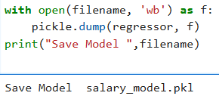

11. Program 2: Streamlit Salary Predictor App
import streamlit as st
import pickle

model = pickle.load(open("salary_model.pkl", "rb"))

with st.form("Salary Predictor App"):

st.title("Salary Predictor App")

input_data1 = st.number_input(
"Enter Years of experience",
min_value=0.0,
max_value=40.0
)

submit = st.form_submit_button("Submit")

if submit:
prediction = model.predict([[input_data1]])

st.write(f"Predicted Salary is {prediction[0]}")

12. Running the Streamlit Application
Open terminal or command prompt and run:
streamlit run app.py

Output:
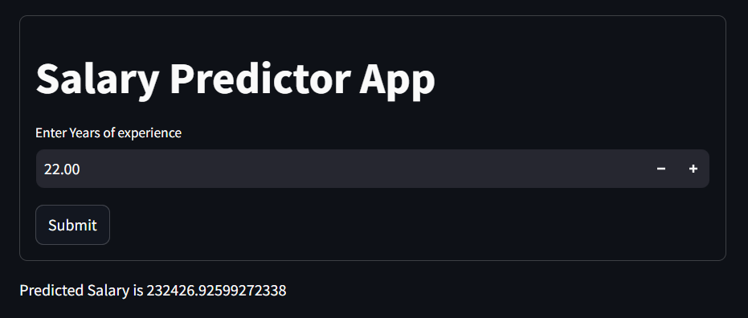

13. Output
- A Streamlit web page opens in the browser.
- User enters years of experience.
- Clicking the Predict Salary button displays predicted salary.
- The Linear Regression model learns salary trends from training data.
- The trained model is saved as salary_model.pkl.
- Streamlit loads the saved model.
- User input is taken through the web interface.
- The application predicts salary instantly.

14. Result
The end-to-end machine learning Salary Predictor application was successfully developed using Linear Regression, Pickle, and Streamlit.

15. Conclusion
Streamlit provides a simple and efficient way to deploy machine learning models as interactive web applications. Combining Streamlit with Pickle allows trained models to be reused effectively in real-world prediction systems.

16. Viva Questions

1. What is Streamlit?
Streamlit Streamlit is an open-source Python framework used to build interactive machine learning and data science web applications quickly and easily.

2. What is an end-to-end machine learning application?
An end-to-end machine learning application is a complete system that includes:
- Data collection
- Model training
- Model saving
- User interface creation
- Prediction generation
- Deployment for real-world use

3. Why is Pickle used in machine learning?
Python Pickle is used to save trained machine learning models into files so they can be reused later without retraining.

4. What is Linear Regression?
Machine Learning Linear Regression is a supervised machine learning algorithm used to predict continuous numerical values based on the relationship between input and output variables.
The Linear Regression equation is:
y = mx + c
Where:
- y = Predicted value
- m = Slope
- x = Input variable
- c = Intercept

5. What is model deployment?
Model deployment is the process of integrating a trained machine learning model into a real-world application so users can make predictions.

6. What is the purpose of Streamlit widgets?
Streamlit widgets are used to take user input and create interactive web interfaces.
Examples:
- st.button()
- st.number_input()
- st.slider()
- st.text_input()

7. What is the use of st.button()?
The st.button() function creates a clickable button in a Streamlit web application.

Example
if st.button("Predict"):
print("Button Clicked")

8. How is user input taken in Streamlit?
User input is taken using Streamlit input widgets such as:
- st.number_input()
- st.text_input()
- st.selectbox()
- st.slider()

9. What is the purpose of pickle.load()?
The pickle.load() function is used to load a previously saved machine learning model or Python object from a file.

Syntax
pickle.load(file)

10. What command is used to run a Streamlit application?
The following command is used to run a Streamlit application:
streamlit run app.py

Experiment No. 13.2

An End-to-End ML Application using Flask: Purchase Predictor App

1. Aim
To develop an end-to-end machine learning web application using Flask for predicting product purchase behavior using the Social_Network_Ads.csv dataset and Pickle.

2. Objectives
- To understand end-to-end machine learning workflow.
- To build a classification model using machine learning.
- To save the trained model using Pickle.
- To develop a web application using Flask.
- To predict purchase behavior based on user input.

3. Software Required
- Python 3.x
- Flask Framework
- Pandas Library
- NumPy Library
- Scikit-learn Library
- Pickle Module
- HTML/CSS (for frontend page)
- VS Code / PyCharm / Jupyter Notebook

4. Introduction
Machine learning models become highly useful when deployed as web applications.
Flask Flask is a lightweight Python web framework used to develop web applications and deploy machine learning models.
In this experiment:
- A classification model is trained using the Social_Network_Ads.csv dataset.
- The trained model predicts whether a customer will purchase a product based on Age and Estimated Salary.
- The trained model is saved using Pickle.
- A Flask web application is created to interact with the model.

Applications
Application | Purpose
Purchase Prediction | Predict customer buying behavior
Spam Detection | Identify spam emails
Loan Approval | Predict loan eligibility
Disease Prediction | Predict diseases using symptoms

5. About Flask
Flask is a micro web framework written in Python.

Advantages of Flask
- Lightweight and simple
- Easy routing system
- Suitable for ML deployment
- Flexible frontend integration

Common Flask Components
Function | Purpose
Flask() | Create Flask application
@app.route() | Define webpage route
render_template() | Render HTML pages
request.form | Get user input
app.run() | Run Flask server

6. Steps in End-to-End ML Application
- Load dataset
- Preprocess data
- Train machine learning model
- Save model using Pickle
- Create Flask application
- Design HTML interface
- Load trained model
- Accept user input
- Predict output
- Display result

7. Dataset Description
- The Social_Network_Ads.csv dataset contains customer information.
- The model predicts whether the customer will purchase a product.

Dataset Attributes
Attribute | Description
Age | Age of customer
EstimatedSalary | Estimated salary of customer
Purchased | Output class (0 or 1)
- Age and Estimated Salary are input features.
- Purchased is the target variable.

8. Dataset Characteristics
- Number of input features: 2
- Target variable: Purchased
- Type of problem: Classification problem

9. Learning Objective
The model learns the relationship between customer information and purchasing behavior.

10. Program 1: Model Training and Saving using Pickle
import pandas as pd
from sklearn.model_selection import train_test_split as tts
from sklearn.metrics import confusion_matrix, accuracy_score
from sklearn.ensemble import RandomForestClassifier
data = pd.read_csv("Social_Network_Ads.csv")

X = data.iloc[:, [2,3]].values
y = data.iloc[:, 4].values

x_train, x_test, y_train, y_test = tts(
X, y, test_size=0.3, random_state=0
)

forest = RandomForestClassifier(
n_estimators=10,
criterion='gini',
random_state=0,
max_depth=2
)

forest.fit(x_train, y_train)

y_pred = forest.predict(x_test)
cm = confusion_matrix(y_test, y_pred)

print("Confusion Matrix:\n", cm)
print(
"\nAccuracy Score:",
accuracy_score(y_test, y_pred) * 100
)

import pickle
pickle.dump(forest, open("Forestmodel.pkl", "wb"))
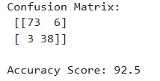

11. Program 2: Flask Application
from flask import Flask, render_template, request
import pickle
import pandas as pd

# Load trained model
model = pickle.load(open("Forestmodel.pkl", "rb"))

app = Flask(__name__)

@app.route("/")
def welcome():
return render_template("form1.html")

@app.route("/predict", methods=["POST"])
def predict():

age = request.form.get("age")
salary = request.form.get("salary")

result = model.predict([[age, salary]])[0]

if result == 1:
return render_template(
"form1.html",
label=1
)
else:
return render_template(
"form1.html",
label=-1
)

if __name__ == "__main__":
app.run(debug=True)

Output:
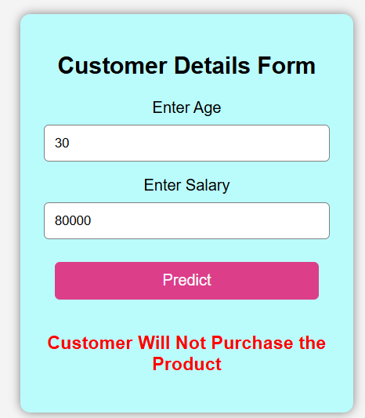

13. Running the Flask Application
Open terminal or command prompt and run:
python app.py

14. Output
- A Flask web page opens in the browser.
- User enters Age and Salary details.
- Clicking the Predict button displays purchase prediction.
- The Random Forest model learns customer purchase behavior.
- The trained model is saved as Forestmodel.pkl.
- Flask loads the trained model.
- User inputs are processed through the web interface.
- The model predicts whether the customer will purchase the product.

15. Output Explanation
- The Random Forest model learns customer purchase behavior.
- The trained model is saved as Forestmodel.pkl.
- Flask loads the trained model.
- User inputs are processed.
- The model predicts whether the customer will purchase the product.

16. Result
The end-to-end machine learning Purchase Predictor web application was successfully developed using Flask, Random Forest Classifier, and Pickle.

17. Conclusion
Flask provides an efficient platform for deploying machine learning models as web applications. Combining Flask with Pickle enables reusable and interactive prediction systems for real-world applications.

18. Viva Questions

1. What is Flask?
Flask Flask is a lightweight Python web framework used to build web applications and deploy machine learning models.

2. What is machine learning deployment?
Machine learning deployment is the process of integrating a trained machine learning model into a real-world application so users can make predictions using the model.

3. Why is Pickle used in machine learning?
Python Pickle is used to save trained machine learning models into files so they can be reused later without retraining.

4. What is Random Forest?
Machine Learning Random Forest is a supervised machine learning algorithm that combines multiple decision trees to improve prediction accuracy and reduce overfitting.

5. What is the use of Flask routing?
Flask routing is used to define URLs and connect them to specific functions in the application.

Example
@app.route("/")
def home():
return "Welcome"

6. What is the purpose of render_template()?
The render_template() function is used to display HTML pages in a Flask application.

Example
return render_template("index.html")

7. What is the role of HTML in Flask applications?
HTML is used to create the frontend user interface of Flask applications. It helps display forms, buttons, text, and user inputs in the browser.

8. What command is used to run a Flask application?
The following command is used to run a Flask application:
python app.py

